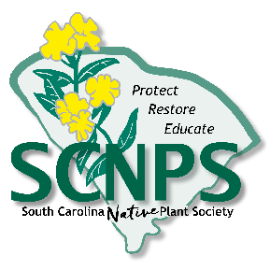
South Carolina Native Plant Society – Lowcountry Chapter
Community Grant Program:
Community Project Funding Criteria

February 2022

Community Projects must be directed at protecting, preserving, restoring, and/or education the public about native plants or plant communities in the Lowcountry of South Carolina (we will only consider projects in Beaufort, Berkeley, Charleston, Colleton, Dorchester, Georgetown, and Horry counties). Priority will be given to those projects involving public land, cultural significance, rare species, or the removal of invasive/exotic species.
Requirements:
- Applicants must demonstrate that they have means (capacity, time, etc.) available to complete and maintain the project.
- If applicants do not own the property, they must provide documentation that permission has been granted by property owner for the project. Community project funds are not to be used on personal property or for personal gain.
- Projects should be scheduled to begin within one year of issuance. Awardees are required to provide proof of project completion, such as photos or maps (if applicable).
- After completion, a tour of the project site or a presentation about the project during a SCNPS Lowcountry monthly meeting (at the Citadel or online) is required.
- Applicants may only apply for one project per fiscal year.
For consideration, applicant must submit an application (maximin of 3 pages) that includes
- Project contact (including phone number and email address)
- Location
- Budget (include any matching funds – source and amounts)
- Description of how this project benefits or demonstrates the value of native plants
- Discussion of whom the project will affect and how
- Timeline for completion
- Description of how project will be sustained/maintained over time
- Letters of support from identified partners and/or landowners
Award amounts: Individual award amounts will not exceed $1,000. Awards will be given at the discretion of the Board of the Lowcountry Chapter of the SCNPS.
Application deadlines: Spring 2022 proposals will be accepted until March 1st and awarded by April 1st.
Contact: For additional information and to submit your application electronically (preferred), please e-mail Matt Johnson at scnps.lowcountry.president@gmail.com. Applications may also be submitted by mail:

SCNPS Lowcountry Chapter
P.O. Box 71604
North Charleston, SC 29415

