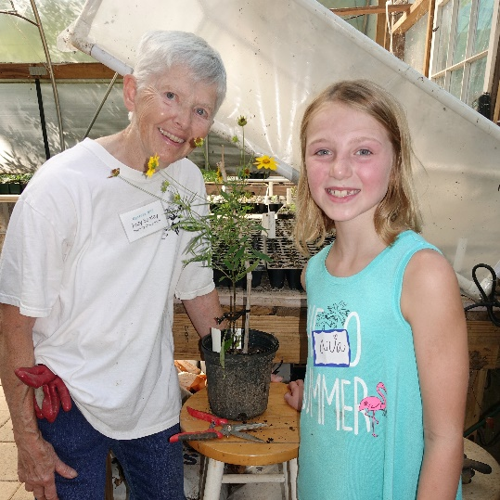
VOLUNTEERING:
Every Little Thing Counts!
“The good stuff adds up…every little thing counts. Every small kindness, every generous gesture, every moment of care and intention….it all adds up.”

In his recent book John Kasich talks about how we as individuals can make a difference in our communities, our nation, our world. The words seemed particularly applicable to the work of our many SCNPs Upstate volunteers. Here are some other quotes. Kasich continues…
Judy Seeley & Ava Hardin in the Upstate Greenhouse by D.Lockard
“We need to start sharing ideas on the best ways to develop our personal power…to answer some kind of call, because we feel we have something to contribute…some special skill set or talent that could help to make our (community) a better place. Because it’s on each of us to serve in our own way.”

Please join us to enjoy and learn more about native plants and to help our community come to understand and appreciate the vital role native plant species play in the health and sustainability of our natural ecosystem! We encourage you to find some small way to bring your skills, your ideas, your energy to help achieve our goals which are posted on our website. Upstate@scnps.org

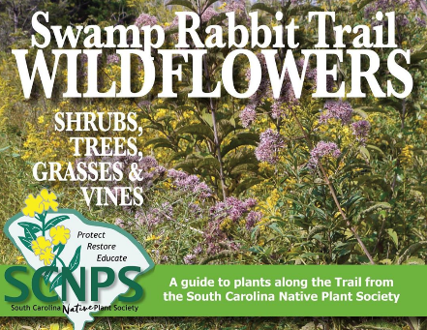
ACTIVITIES
Wild Plants on the Swamp Rabbit Trail
A new edition of the Wild Plants on the Rabbit pocket-sized brochure was released in in October and more than 2,500 copies are now available in more than two dozen establishments in Greenville & Travelers Rest. This brochure showcases over 100 native and naturalized plants on the popular 20-mile Prisma Swamp Rabbit Trail. In addition to a few more plants, the revised brochure's map includes the proposed Laurens Road corridor extension. Get your copy and get out there and experience this amazing Upstate trail. GET YOUR COPY

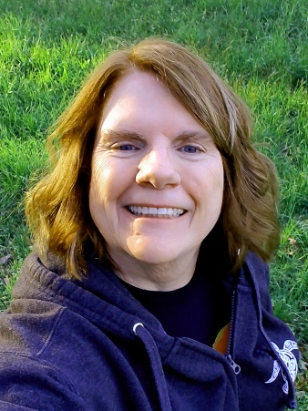
PROFILES
Kathy Harrington, Plant Sales Chair & Board Member
Kathy Harrington, a retired pharmacist, joined SCNPS in 2016 and currently serves on the SCNPS Upstate Board of Directors as the Chairperson for the Plant Sale Standing Committee. It is an important job since the sales represent about 85% of our Upstate chapter revenue each year and is a year-long program involving dozens of volunteers. If that weren’t enough, Kathy also volunteers on the Greenhouse Gang for the propagation of hundreds of plants each year, and on the Greenhouse Steering Committee. To learn more about Kathy and other movers and shakers in the Upstate check out our new Upstate Team page on our website! MEET THE TEAM

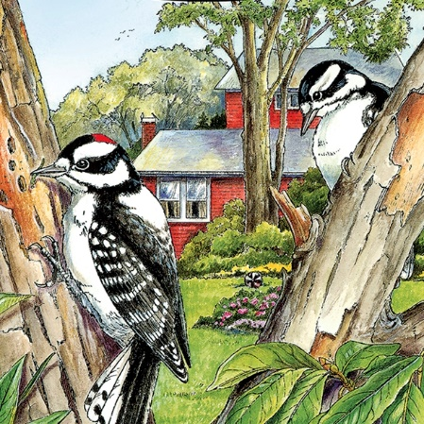
BOOK REVIEW:
Children’s Coloring Books
One of the guiding goals of the SCNPS is informing our communities about native plants. Which plants are and are not native, how our plants and wildlife have evoloved together and why they are vital to supporting our wildlife in our habitat That learning experience can begin with a simply coloring book, a couple of crayons and a child.
There are some excellent coloring books available on Amazon or our partner The Complete Naturalist in Asheville. We've included a few samples of this on our website's new Children’s Page, These samples are important South Carolina native plants and the wildlife they support that you can print and share with your children or grandchildren. Even better if you have them growing in your own yard for the kids to see in real-life.

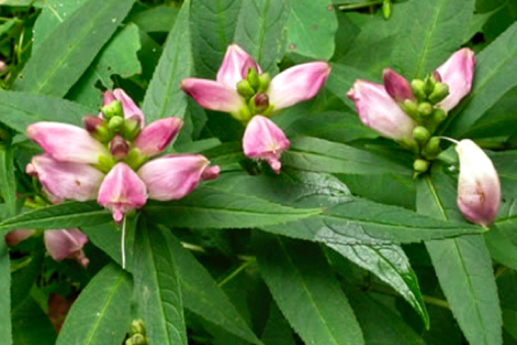
LEARNING:
The Native Hikes Project
The ‘Citizen Scientist’ has long been the mainstay of scientific advancement in the world, and no less today than in Darwin’s time. In this essay, Doug Lockard reports on native species observations along his favorite hike trail at Paris Mountain. He also discusses the latest technology in plant identification aps that enable novice enthusiasts to contribute meaningful and timely data collection. Read the story! https://scnps.org/activities/native-hikes-project

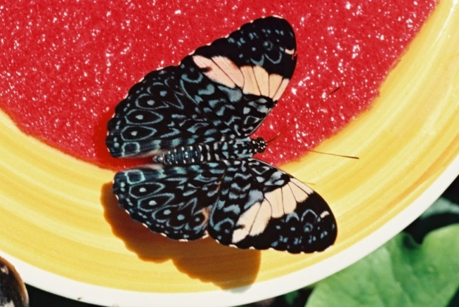
GARDENING:
Winter Gardening for Wildlife
Fall is here and with it brings new opportunities for gardeners to provide meaningful support in our Living Gardens by providing food, water and shelter for the diverse range of South Carolina’s beneficial insect’s. While human attitudes about Autumn seem to run the gamut from joy to welcome relief to sadness, for our wildlife, it’s about survival; about finding food, water sources and safe shelter that’ll take them through the winter months, and about reproduction. In this essay, we’ll make you aware of some of the impact you can have in your own ‘Living Landscape’ by adopting some practices that will make life a little easier for our beneficial wildlife. READ MORE
Red Cracker by D.Lockard

