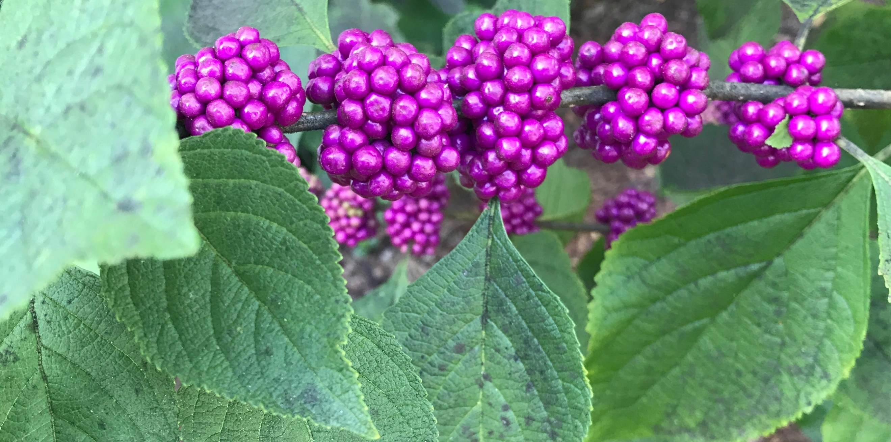
Native Plant Week
October 14-21

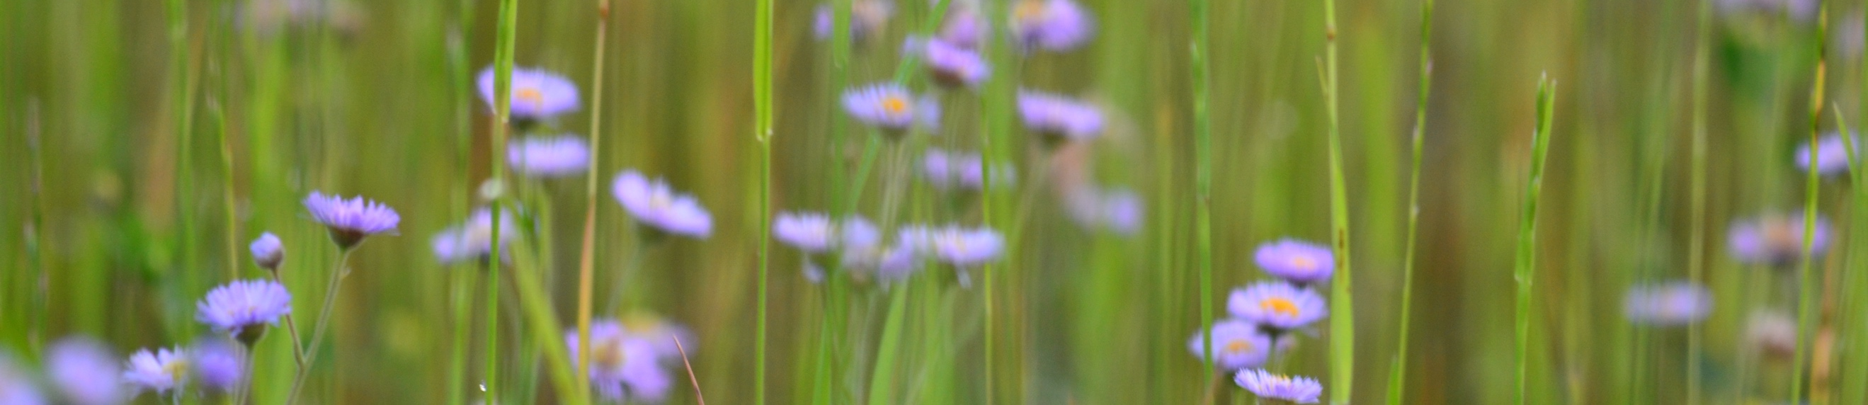
October 14th, Saturday

Pollinator Propagators Workshop and Volunteer Garden Installation

The Bend
3775 Azalea Dr, North Charleston, SC
9:00 am - 11:00 am
Join us at The Bend to help construct a Native Plant raised garden bed on Saturday October 14th from 9-11 am. Master Gardeners will be on site to provide guidance and instruction on how to create a raised bed for native wildflower seeds and planting native plants in your own yard. Participants will receive their own packet of seeds for a 5x5 ft plot to create their own pollinator garden and habitat at home. Please register in advance as space is limited. Bring Water and wear your gardening attire, and closed toed shoes. This project is in cooperation with Clemson Extension, The South Carolina Native Plant Society, The Bend, and Audubon South Carolina.
Register at:

Native Plant and Seed Swap

Good Shepard Lutheran Church
3909 Forest Dr, Columbia SC – Upper Parking Lot
10:00 am – 12:00 pm
Bring native plants and native plant seeds that are identified to the swap. Tables will be provided and those who don’t bring seeds or plants will still be given some.

Upstate Greenhouse Native Plant Sale

180 Lakewood Dr.
Greenville SC
October 14th -15th
9:00 am – 2:00 pm
Bring native plants and native plant seeds that are identified to the swap. Tables will be provided and those who don’t bring seeds or plants will still be given some. Place orders online now and plants can be picked up at the sale. See scnps.org for more details

Spring Island Plant Sale

Spring Island Trust, Native Plant Project
Spring Island Native Plant Nursery
Spring Island will hold it’s Native Plant sale consisting of native plants propagated and rescued from the area.
http://npp.springislandtrust.org/plant-sales/upcoming-sales.html

October 15th, Sunday

Piedmont Chapter Native Plant Display

The Museum of York County
4621 Mount Gallant Rd, Rock Hill, SC 29732
October 16th- 20th
There will be a Native Plant display at the Naturalist Center. Table Displays will include Native grasses, wildflowers, trees, and invasive species.

Katawba Valley Land Trust Anniversary Event

Ivy Place
Van Wyck, SC
October 15th
1:30 pm - 6:00 pm
Representatives from the Piedmont chapter will be providing a native plants educational table and display at this afternoon event as a part of the Katawba Valley Land Trust’s 25th Anniversary Celebration.

October 16th, Monday

Dan Whitten Talk “Nature’s Store”

Health Science Building of Spartanburg Community College
107 Community College Dr, Spartanburg SC.
7:00 pm

President of the Upstate Native Plant Society Chapter, Dan Whitten, will give a talk to the Spartanburg Men’s Garden Club about edible and medicinal plants.
October 17, Tuesday

Dr Porcher Lecture, Rediscovering the Lowcountry Landscape in the Footsteps of Our Forebears

Founder’s Hall, Charlestowne Landing
1500 Old Towne Rd, Charleston SC, 29407
Doors open at 5:30 pm, lecture starts at 6:30 pm
Join us for a lecture by Dr. Richard Porcher, Author/Historian and Celie Dailey, Author/Artist. Doors will open at 5:30 pm, with the program to begin at 6:30 pm, with a reception to follow. This event is free for SC Native Plant Society and Audubon members and sponsors. Guests are welcome for a $5 donation.
http://scnps.org/event/lowcountry-dr-richard-porcher-lecture

Lecture: Why We Advocate for Native Plants Talk (and we’re not being Xenophobic)

Clemson University Emeritus College
Clemson University, Clemson, SC
11:00 am
The Upstate Chapter of the Native Plant Society will host Bill Stringer discussing Native Plants and why we advocate for them.

Upstate Meeting:
Invasive Species, Early Detection, Rapid Response and you

Landrum Depot
211 North Trade, Landrum SC
6:30 pm – 9:00 pm
Dr. Lauren Serra will speak about the advancing front of invasive species, early detection, rapid response, and exotic plant management team efforts to control spread.

October 19th, Thursday

Birding and Botanizing at Old Santee Canal Park

Old Santee Canal Park
900 Stony Landing Rd, Moncks Corner, 29461
8:30 am – 10:30 am
Join Audubon staff for birding and botanizing as we celebrate native plant week in South Carolina! This walk will be a combination of birding and discussing why native plants help birds, making it a perfect fit for birders, gardeners, and more! We'll meet at 8:30 a.m. in the parking lot at the park, and as a reminder there is a $3/person fee to participate. All ages and experience levels invited and we’ll have extra binoculars to share. Registration for this event is optional but encouraged - to register, visit our Meetup or Facebook events page. For questions, e-mail mgjohnson@audubon.org.
http://sc.audubon.org/events/fall-bird-walks-old-santee-canal-park-1

Elliotborough Garden Party and Native Plant Celebration

Elliotborough Community Garden
128 Line Street, Charleston SC
5:30 pm – 8:30 pm
Join Audubon South Carolina and Charleston Audubon for a Garden party and Celebration of Native Plant. Elliotborough Community Garden received a Native Plant garden and bird and bat box installation with the help of the Holloman-Price grant. Come enjoy free food, drinks, and live music while browsing native plants from Roots and Shoots Native Plant Nursery, bird and bat boxes from Wild Birds Unlimited, information from Clemson Extension, and local Monarch expert Billy McCord with a butterfly tagging demonstration. Parking is limited on the street. Please carpool, rideshare, or plan on walking from a nearby public parking lot. Space is limited so please register ahead of time: Register online: http://tinyurl.com/ASCGardenParty

October 20th, Friday

Holy City Brewery Native Plant Celebration

Holy City Brewery
4155 Dorchester Road, North Charleston, SC 29405
5:00 pm – 9:00 pm
We’ve partnered with the best brewery in Charleston for this relaxing evening of pints and plants! Stop by Holy City Brewery and have a beer with us as we toast to native plants and a fun-fill inaugural native plant week. And to top it all off, our friends at Holy City have been generous enough to donate $1 from all Washout Wheats sold this evening to the SC Native Plant Society! This will be a relaxing evening, so stop by, have a drink and dinner, and visit our booth to learn more about native plants and our upcoming native plant sale!

October 21st, Saturday

Lowcountry Native Plant Sale

Charlestowne Landing
1500 Old Towne Rd, Charleston SC, 29407
8:00 am – 12:00 pm

Admission to the plant sale is free. If exploring Charles Towne Landing on your own, please pay entrance fee at the visitor center. Sale to include: colorful perennials, trees, shrubs, ferns, native grasses, and edibles. Native plant list and prices to be posted on the SCNPS website a few weeks before the sale. Cash, check, or credit card accepted. For more information or to sign up as a volunteer please contact Eddie Bernard at edlbernard@aol.com or 843-270-1112. All proceeds from the plant sale benefit the Lowcountry chapter of the SC Native Plant Society, a non-profit organization committed to the preservation and protection of native plant communities in South Carolina.

http://scnps.org/event/lowcountry-fall-plant-sale

Seed Collection Field Trip

Rock Hill Blackjacks Heritage Preserve
970 Blackmon Rd, Rock Hill, SC
10:00 am

Bill Stringer, with the Piedmont Chapter will lead a seed collection field trip to the Rock Hill Blackjacks Heritage Preserve. Meet in the Blackmon Rd parking lot at 10 am.

